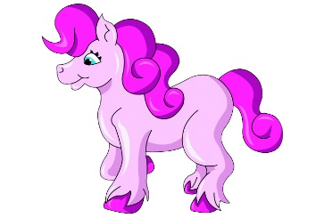

THINK PINK QUALIFICATION

Youngstock
Qualifications are given to the highest placed two, not to have already qualified in the top six. Qualification Cards will be provided to qualifying competitors.

Should there be more than 5 yearlings entered in the youngstock class, they will be split at the Finals.

Young Handler under 16
Qualifications are given to the highest placed two, not to have already qualified in the top six. Qualification Cards will be provided to qualifying competitors.

Diamond Show – 21st June 2015
The winner from every in hand and ridden showing class at the show held on 21st June 2015 qualify for the Think Pink Diamond Finals

The finals are to take place on the 5th September 2015 at Norton Heath Equestrian Centre, Fingrith Hall Lane, Blackmore, CM4 0JP. The final classes will be split. The top ten from each final will go through to the evening performance for placing, Evening turnout encouraged. All finalists to receive a rosette. Think Pink shows raise money for Cancer Research UK. Find us on Facebook or www.thinkpinkshow.co.uk

Qualifiers at Shows between May & August inclusive.

Please see Classes for any additional rules specific to that class.

