DDRC CLUB RULES

- Riding Jackets, jodhpurs and Riding Boots must be worn by all mounted competitors. Un-mounted competitors should be correctly dressed for showing.
  - In the case of extreme hot weather, riding jackets may be forfeited but a white long sleeved shirt/blouse must be worn. This is at the judge’s discretion.
- Riding hats with chinstraps must be worn by all persons when mounted on any horse/pony on any part of the showground. Hats must be according to current standards brought in on 1st January 2016. Failure to comply will result in disqualification from the competition if already competed, or if not already competed, you will not be able to compete until you have found a hat which complies to the standard.
- It is the rider/handler’s responsibility to ensure their horse/pony is tacked up correctly. Random spot checks may be carried out.
- Chinstraps must be fastened at all times. Failure to do so will result in automatic elimination.
- All animals on the showground must be sound and in good condition.
- The organizers reserve the right to refuse any entry to any class or entry to the showground without stating a reason
- No entries will be accepted unless accompanied by the correct fee and all cheques must have the name and address of the signatory on the reverse of the cheque or they will not be accepted.
- The organizers reserve the right to request a height certificate of any animal and proof of age of riders where there is an entry requirement We also reserve the right to measure any horse/pony Please note that for veterans and young stock a copy of a passport must be available on request.
- Objections must be made within 30 minutes of the incident and accompanied by a deposit of £20.00 which will be forfeited if the objection is overruled
- The organizers will not accept any responsibility or liability for loss, damage or illness to any property, person or animal however caused
- Dogs must be kept on a leash at all times on any part of the showground.
- No horse or pony under the age of 4 years may be ridden on the showground
- No galloping or cantering on the showground is allowed except as required by a judge or in the practice areas.
- Improper use of whips or spurs at any time on the showground will result in elimination. The wearing of Spurs is allowed in Ring 1 from 70cm upwards.
- A riders age will taken as from January 1st 2024
- Club membership runs from January 1st - December 31st.
- Points will only be awarded from the date of MEMBERSHIP RENEWAL or in the case of a new member, the DATE OF JOINING the club.
- Members must attend a minimum of 2 shows during the year to qualify for the DDRC points system.
- The ruling of any judge or official is final and any person found arguing will be asked to leave the showground
- Any person found mistreating any animal or using bad language will be asked to leave the showground
- A combination can enter no more than 4 classes of which no more than 3 can be a SJ/WH
- The organizers reserve the right to either alter or cancel any class and to amalgamate any class where there are insufficient entries
- Points are accumulated on rider/horse or pony and handler/horse or pony and not on a membership basis. Horse/pony names must remain the same throughout the season (if the horse is the same horse).
- Once the rope on the showing rings has been fastened, there is STRICTLY no admittance to the ring by any competitors.
- A horse or pony may now jump hors concours immediately after its competitive round and not wait until the end of the class. The horse/pony who has jumped hors concours will remain hors concours in that ring for the rest of the day.

SUNSHINE TOUR RULES
This show is a qualifier for The Sunshine Tour Championship held at The All England Jumping Course, Hickstead from Thursday 12th – Sunday 15th September 2024. The Championships are for unaffiliated and amateur competitors of in Dressage from Intro to Elementary, Showjumping from Lead Rein to 1.0m, Showing for lead rein, in hand, ridden, working hunter, veterans, plus many more.
Qualification: Dressage & Show Jumping 1st – 3rd place; Showing & Eventers Challenge 1st – 4th place. Qualification does not pass down the line.
Registration of qualification must be completed within 1 month of competition (sooner for late July shows). Restrictions apply to both horse and competitor’s previous winnings and amateur status, please check the website for Terms & Conditions.
Visit www.sunshinetour.co.uk for more information, to register and submit evidence of results.
Qualifying Shows are between April and July 2024.

ESUK CHAMPIONSHIP RULES

This show is affiliated to Equine Sports UK (ESUK) Grassroots Championships taking place at Arena UK, Grantham, Lincolnshire on the 25th-27th July 2024. The three highest placed exhibits will qualify in each class.

To register go to https://equinesportsuk.com/register/registration-form. Please only register once! If you are in doubt about whether you have already registered AND/OR have misplaced your membership number, please email info@equinesportsuk.com.

DDRC Shows between April and September 2024 inclusive include qualifiers for ESUK.

Qualifiers for ESUK 2024 will run until 21st July 2024. Qualifiers for ESUK 2025 will run from the 22nd July 2024. Shows after this date will automatically be included for ESUK 2025.

Equine Sports UK Grassroots Championships are held solely for grass-roots competitors. We respectfully remind all competitors to enter in the spirit of grassroots championships.

To avoid confusion our definition of Grassroots is as follows:
Definition of a grassroots rider - a person who engages in the most basic level of horse-riding (as opposed to an amateur - a person who engages in a pursuit, especially a sport, on an unpaid basis)

The following restrictions apply and are excluded from the Championships:
Professional Riders, (those who make a full-time living out of buying, selling, producing, breaking, schooling, teaching, grooming, training or competing).
Horses/Ponies/Riders combination not to have qualified or competed in any classes at Olympia, RIHS or Horse of the Year Show including Search for a Star in the past five years.
Rider not to have ridden at Olympia, RIHS, Horse of the Year Show including Search for a Star in the past five years.

IF YOU HAVE ANY DOUBT ABOUT YOUR ELIGIBILITY TO COMPETE AT ESUK, PLEASE CONTACT US BEFORE ENTERING.
WE RESERVE THE RIGHT TO DISQUALIFY ANYONE WHO ENTERS THE CHAMPIONSHIPS IF THEY ARE REPORTED AND FOUND TO BE INELIGIBLE.

Veteran Horse Society – AREA QUALIFIER 2024.

First round qualifier for the Veteran Horse Society Supreme Final:
VETERAN HORSE OF THE YEAR 2024

Open to members and non-members. All competitors and grooms must adhere to VHS Rules in all circumstances. Failure to do so may result in immediate disqualification.

VHS Regional Final qualification. All competitors placed 1st to 4th in each age category will qualify for the corresponding class at VHS Regional Finals. Members must carry their cards in the ring and have their showing card signed by the judge in the ring as proof of qualification. Non-members will receive a red qualification card which can be exchanged for signed showing card when applying for VHS membership. This MUST be done within 21 days of qualification. It is the competitors responsibility to present their Showing card to the judge.
Regional Finals are open to members only.

All competitors are eligible to enter open classes at the National Veteran Championships, to be held at Arena UK Lincolnshire on 30th August – 1st September 2024. No qualification or membership necessary. See VHS website for schedule which is available mid-season 2024.

For further information please visit the VHS website www.veteran-horse-society.co.uk or telephone the VHS Show Office on 01239 881300 or 07789 514004.

CLASS 19 | VETERAN IN-HAND, COMBINED AGE CLASS (15 years and over).  To be run as one class but judged as separate age categories:  Diamond Veteran (25 years and over), Veteran (20–24 years) & Pre-Veteran (15–19 years). Open to horses and ponies of any breed and height.
CLASS 30 | VETERAN RIDDEN, COMBINED AGE CLASS (15 years and over).  To be run as one class but judged as separate age categories:  Diamond Veteran (25 years and over), Veteran (20–24 years) & Pre-Veteran (15–19 years). Open to horses and ponies of any breed and height.

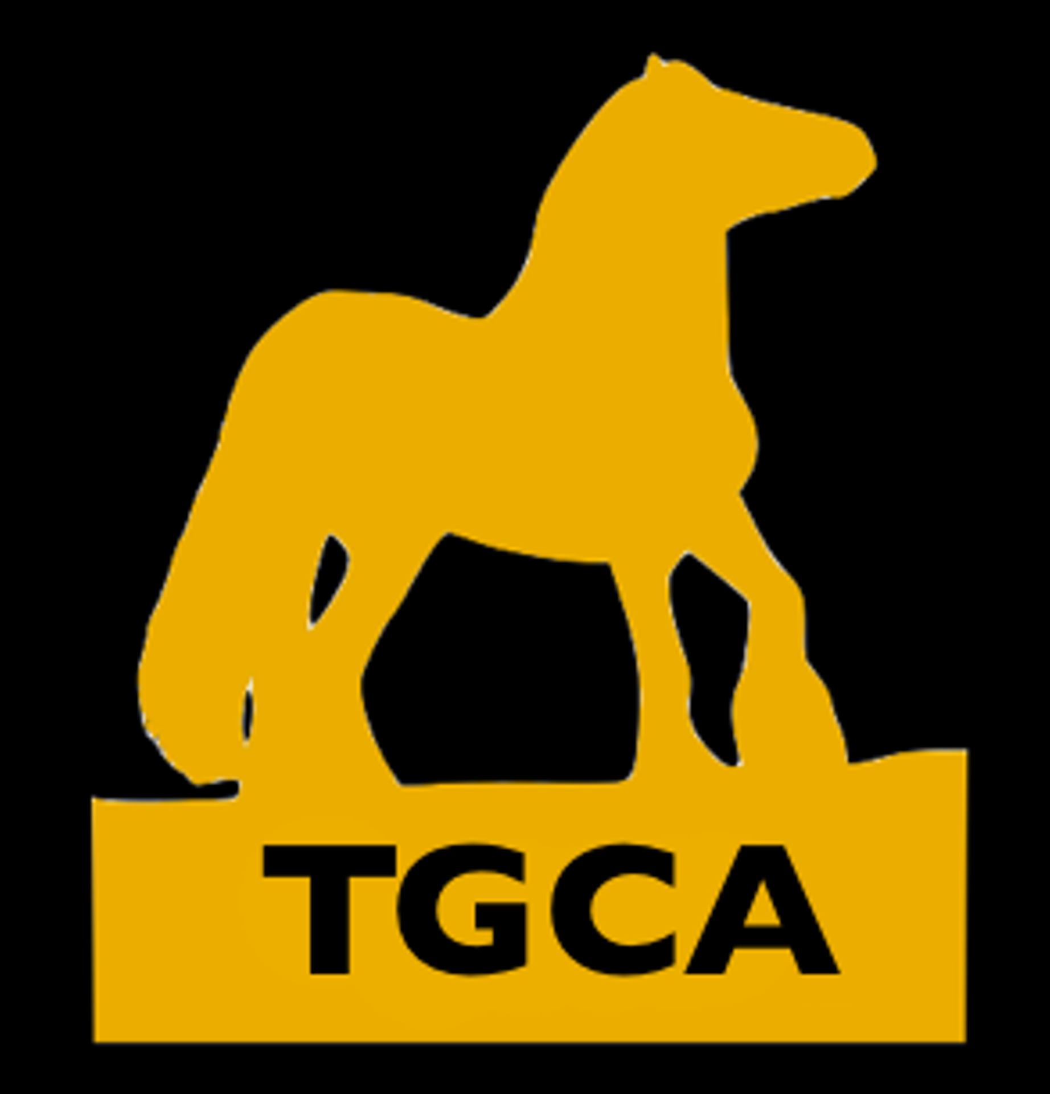
TGCA TOYS In Hand and Ridden Classes

No known breeding required to enter these classes

No Membership required to Enter these Classes

TGCA Classes at Dacorum & District Riding Club - Affiliation No - 24/2104/3/STQ.

TGCA Breed classes are qualifiers for the Best of Breed Finals at the Traditional Gypsy Cob Association's (TGCA) National Breed Championship Show “TOYS”.

Traditional Classes are open to all traditional gypsy cobs and are qualifiers for the Traditional Finals at ‘TOYS’.

Part Bred classes, are open to all part bred traditional gypsy cobs and are qualifiers for the part bred finals at “TOYS”. The exhibit must have one parent that is a traditional gypsy cob.

Stallions – All stallions (four years and over) in order to enter any TGCA affiliated class MUST be TGCA registered, have passed TGCA stallion evaluations and their TGCA stallion disc displayed on their bridle. Stallions and colts over the age of two, MUST be shown in a stallion bridle with a metal bit and chain lead as per the current TGCA rulebook.

Current TGCA members must present their Membership card and Qualification card to the judge in the ring for signature.

Non-members MUST receive a qualification card from the judge and have 21 days to join the TGCA and register their horse to validate the qualification. Please refer to www.tgca.co.uk for further details including membership, horse registration and showing rules (contained within the members handbook).

Championship

Quest for a Star Championship inc Youngstock Quest for A Star - TGC - 1st, 2nd and 3rd from the TGCA classes above may go forward to the Quest for a Star Championship as per below rule.

ONLY current TGCA members and horse/pony that is already TGCA registered can exhibit in this championship. If exhibit already has their Quest for a Star Qualification in particular section, they should be ask stand aside to allow members that have not yet qualified.

Membership card and Members qualification card (specific to that exhibit) must be presented upon entry into the ring. The Champion and Reserve qualify for the Ultimate Star Championships at TOYS.

The Greatest Gelding Award – TGC - The award is aimed to encourage the showing of geldings, therefore creating a market for often unwanted colt foals and enabling the creation of a network of potential performance prospects to represent the best Traditional Gypsy Cob breed in the World at the highest level.
This Award should be given to the highest placed registered Traditional Gelding. The judge will award this within the classes/championship.

Qualifier Show is June at DDRC.

Qualifier classes are as follows:
Youngstock (Class 8)
In Hand Cobs (Class 9)
Ridden Cobs (Class 10)
EQUIFEST SHOWING QUALIFIER RULES

This Show is affiliated to Equifest, taking place at the Arena UK, Grantham, Lincolnshire on the 1st – 4th August 2023. The two highest exhibits not already qualified in each affiliated class will qualify.

Qualifiers for Equifest 2024 will run from the 1st August 2023 - 30th July 2024. Shows held after this date will be qualifiers for Equifest 2025.

1. EQUIFEST OPEN MOUNTAIN & MOORLAND IN HAND (DDRC Classes 17 & 18)
Open to In Hand Mountain & Moorland ponies registered with their respective Pure Bred Societies of Connemara, Dales, Dartmoor, Exmoor, Fell, Highland, New Forest, Shetland, Welsh A, B, C and D. Stallion, mare, colt, filly or gelding, any age.
Classes may be divided according to entries.

2. EQUIFEST OPEN RIDDEN MOUNTAIN & MOORLAND (DDRC Class 34)
Open to Mountain & Moorland ponies registered with their respective Pure Bred Societies of Connemara, Dales, Dartmoor, Exmoor, Fell, Highland, New Forest, Shetland, Welsh A, B, C and D. Stallion, mare or gelding, 4 years old and over. Rider any age.
Classes may be divided according to entries.

7. EQUIFEST OPEN SHOW PONY LEAD REIN (DDRC Class 28)
Leading Rein Pony, mare or gelding, 4 years old & over not exceeding 128cms. Riders not to have attained their 8th birthday before 1st January in the current year. To be led by an attendant and shown in a snaffle bridle. Lead rein to be attached to the noseband only.

8. EQUIFEST OPEN SHOW PONY FIRST RIDDEN (DDRC Class 29)
First Ridden Pony, mare or gelding, 4 years old and over, not exceeding 128cms. Riders not to have attained their 10th birthday before 1st January in the current year. To be shown in any suitable bridle.

12. EQUIFEST OPEN WORKING HUNTER PONIES (DDRC Class 39)
Working Hunter Pony, mare or gelding, 4 years old and over, not exceeding 153cms. Riders must be the correct age for the animal they ride. If this classification is run as one class, fences must be adjusted for each height section. Classes may be divided as follows:

- Mare or gelding, 4 years old and over, not exceeding 133cms. Riders not to have attained their 14th birthday before 1st January in the current year.
- Mare or gelding, 4 years old and over, exceeding 133cms but not exceeding 143cms. Riders not to have attained their 17th birthday before 1st January in the current year.
- Mare or gelding, 4 years old and over, exceeding 143cms but not exceeding 153cms. Riders not to have attained their 20th birthday before 1st January in the current year.
- Open Intermediate Working Hunter, mare or gelding, 4 years or over, exceeding 148cms and not exceeding 158cms. Riders not to have attained their 25th birthday before 1st January in the current year.

HEIGHT OF FENCES FOR OPEN WORKING HUNTER PONY CLASSES:
CLASS | MINIMUM HEIGHT | MAXIMUM HEIGHT | MAXIMUM SPREAD
Not exceeding 133cm | 70cms | 85cms | 85cms
133cms – 143cms | 75cms | 90cms | 90cms
143cms – 153cms | 85cms | 100cms | 100cms
148cms – 158cms | 95cms | 105cms | 105cms

The course should consist of not less than 7 fences and should contain a change of direction and a spread fence. The course must be built between the minimum and maximum heights, according to the condition of the ring and the standard of entry. In mixed height classes, the fences must be adjusted according to the heights of ponies in the class and ponies MUST jump within their correct height section.
EQUIFEST SHOWING QUALIFIER RULES

13. EQUIFEST OPEN SMALL HUNTERS (DDRC Class 32)
Open Small Hunter, mare or gelding, 4 years old & over, exceeding 148cms but not exceeding 158cms.
Riders any age.

14. EQUIFEST OPEN RIDDEN HUNTERS (DDRC Class 32)
Open Ridden Hunter, mare or gelding, 4 years old & over, exceeding 158cms. Riders any age.

15. EQUIFEST OPEN WORKING HUNTER (DDRC Class 39)
Stallion, mare or gelding, 4 years old and over, exceeding 148cms.
Riders of stallions to have attained their 14th birthday before 1st January in the current year.
Maximum height of fences 1.05m (3’6”) at the discretion of the Judges.

19. EQUIFEST OPEN RIDING HORSES (DDRC Class 36)
Open Riding Horse, mare or gelding, 4 years old and over, any height. Riders any age.
Classes may be divided as follows:
- Small Riding Horses - mare or gelding, 4 years old and over, exceeding 148cms but not exceeding 158cms. Riders any age.
- Large Riding Horses - mare or gelding, 4 years old and over, exceeding 158cms. Riders any age.

20. EQUIFEST OPEN RIDDEN COBS (DDRC Class 35)
Open Ridden Cob, mare or gelding, 4 years old & over, exceeding 148cms but not exceeding 155cms. To be shown hogged and trimmed. Riders any age.
Classes may be divided as follows:
- Open Lightweight Ridden Cob, mare or gelding, exceeding 148cms but not exceeding 155cms. To be shown hogged and trimmed. Riders any age.
- Open Heavyweight Ridden Cob, mare or gelding, exceeding 148cms but not exceeding 155cms. To be shown hogged and trimmed. Riders any age.

21. EQUIFEST OPEN MAXI COBS (DDRC Class 13)

Open Maxi Cobs, mare or gelding 4 years old and over, exceeding 155cms – to be judged as Cobs. To be shown hogged and trimmed. Riders any age.

22. EQUIFEST OPEN RE-TRAINED RACE HORSE (DDRC Class 31)
Thoroughbred mare or gelding, 4 years old & over, any height. Horses must have been raced in the GB to be eligible to compete.

24. OPEN RIDDEN VETERAN HORSE / PONY (DDRC Class 30)
Stallion, mare or gelding, 15 years old and over. Any type or breed. Rider any age.
Classes may be divided according to entries.

25. EQUIFEST IN HAND PIEBALD / SKEWBALD (DDRC Class 14)
Open in Hand Piebald / Skewbald stallion, mare, colt, filly or gelding, any age. The first three places will also qualify for the BSPA Championships subject to their show rules & conditions
Classes may be divided according to entries.

26. EQUIFEST RIDDEN PIEBALD / SKEWBALD (DDRC Class 33)
Open ridden Piebald / Skewbald stallion, mare or gelding, 4 years old & over. Riders any age. The first three places will also qualify for the BSPA Championship subject to their show rules & conditions.
Classes may be divided according to entries.

27. EQUIFEST OPEN IN HAND RIDING PONIES (DDRC Class 20)
In hand Riding Ponies, stallion, mare, colt, filly or gelding. Any age, not to exceed 153cms at maturity.
Classes may be divided according to entries.

BROOK FARM SHOWING CHAMPIONSHIP

This Show is affiliated to Brook Farm TC, with the championship final taking place at Brook Farm on the 25th August 2024. All competitors must be amateur riders and reside in Essex or Hertfordshire to compete at this championship. The three highest placed exhibits not already qualified in each class will qualify. If 1st – 3rd have qualified then qualification passes down to no lower than 4th place. No membership fee is required. Entries close on 22nd August 2024. 1st – 6th in each class will receive a championship rosette. Supreme Champion: £100 Rosette & Sash. Reserve: £50 Rosette & Sash. For more information, please e-mail brookfarmshowing@gmail.com

Record your qualifying place with the venue and date and submit the evidence of your result within one week of competition closing date using PDF, word/excel with subject CHAMPIONSHIP to brookfarmshowing@gmail.com

BROOK FARM CHAMPIONSHIP RIDDEN CLASSES
RIDDEN COB/TRADITIONAL Mare or gelding 4 years & over. Not exceeding 148cms.
RIDDEN HUNTER Mare or gelding 4 years & over exceeding 148cms
RIDING HORSE Mare or gelding 4 years & over. Exceeding 148cms
RIDDEN COLOURED Mare or gelding 4 years & over. Open to horses and ponies
RIDDEN FOREIGN BREEDS incl. ARABS Mare or gelding 4 years old and over. Open to horses and ponies.
RIDDEN MOUNTAIN & MOORLAND Stallion, mare or gelding 4 years & over. To be registered with their respective societies.
RIDING PONY Mare or gelding 4 years & over not exceeding 148cms

BROOK FARM CHAMPIONSHIP IN HAND CLASSES
IN HAND YOUNGSTOCK 1, 2 & 3 year old any breed.
IN HAND MOUNTAIN & MOORLAND Any age. To be registered with their respective societies.
IN IN HAND COLOURED Any age. Open to horses/ponies
IN HAND VETERAN Open to horses/ponies any breed 15 years & over.
IN HAND PONY Any age. Open to ponies not exceeding 148cms.
IN HAND COB/TRADITIONAL Any age. Not exceeding 148cms.
IN HAND FOREIGN BREEDS incl. ARABS Any age. Open to horses and ponies. Stallion, mare or gelding.

