Dacorum and District Riding Club

**Show venue: Westwick Row Farm, Westwick Row, Leverstock Green, Hemel Hempstead, Herts, HP2 4UB**

**SHOW SCHEDULE 2014**

# *MEMBERS AND NON-MEMBERS WELCOME*

# 2015 SHOW DATES

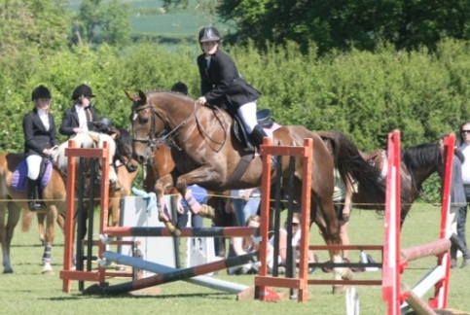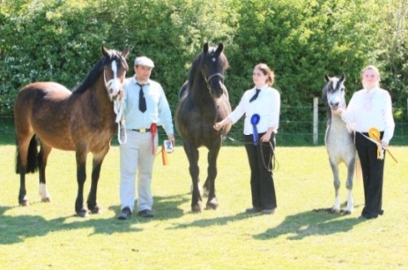**Sunday 17th May**

**\*Sunday 21st June\***

**Sunday 19th July**

**Sunday 16th August**

**Sunday 6th September**

****

**\*Show on 21st June 2015 is a Think Pink Diamond Show\***

**Our shows incorporate Qualifiers for the following:**

## CT Rider Championships

## Think Pink Show

PLEASE RETURN ENTRIES, MEMBERSHIP AND DIRECT ALL ENQUIRIES TO:

DDRC SHOW SECRETARY

DEBBIE SHELDON

[](http://www.google.co.uk/url?sa=i&rct=j&q=follow+us+on+twitter+logo&source=images&cd=&cad=rja&docid=m01Q_RtW-YEoZM&tbnid=lwgkaiMcR97WoM:&ved=0CAUQjRw&url=http://pridelondon.ca/?attachment_id=3779&ei=qkhIUa75G4LQ0QXE9ICgAw&bvm=bv.43828540,d.d2k&psig=AFQjCNG1ILcq_ydmgtgF1Pi3eTgUsMDzwg&ust=13637777945790)15 BOURNEHALL AVENUE

[](http://www.google.co.uk/url?sa=i&rct=j&q=find+us+on+facebook+logos&source=images&cd=&cad=rja&docid=MrjEfJFbIaBHPM&tbnid=sxIPk-1B9iCm4M:&ved=0CAUQjRw&url=http://www.uscb.edu/campus_life/student_services/career-services/students_and_alumni/find_a_job!.php&ei=J0dIUZaLB6Kn0QWAuoH4BA&bvm=bv.43828540,d.d2k&psig=AFQjCNG4K5W4uzDW4z_pyNSW05mwGaWx2A&ust=13637776926345)BUSHEY

HERTS

WD23 3AU

Tel: 0208 950 2656

Email: [enquiries@dacorumridingclub.co.uk](mailto:enquiries@dacorumridingclub.co.uk)

Facebook: [www.facebook.com/dacorumridingclub](http://www.facebook.com/dacorumridingclub)

Follow us on Twitter @dacorumrc

Please visit our website: [www.dacorumridingclub.co.uk](http://www.dacorumridingclub.co.uk)

DACORUM & DISTRICT RIDING CLUB

**COMMITTEE 2015**

**CHAIRPERSON**

Doriel Watson

**SECRETARY**

Debbie Sheldon 0208 950 2656

**SHOW DAY SECRETARY**

Carol Hardy

**MEMBERSHIP & CLEAR ROUND**

Alison Halfnight

**RESULTS ANALYST**

Claire Palmer

**SHOWJUMPING CO-ORDINATION**

Ken Burgin

Tony Field

### **Catch It Quick Photography**

# Event Photography Specialist

EN00297_

# \*Equestrian Events \*Equestrian Portraits

# \*Black Tie \*Charity Events

# View Your Photos

**www.catchitquick.co.uk**

**Tel: 0208 421 9003**

DACORUM & DISTRICT RIDING CLUB

**ACKNOWLEDGEMENTS**

The DDRC committee would like to say a very big thank you to all of those who help, sponsor, advertise, judge and enable us to continue running of this club, not to mention our members and competitors.

The Bell-Taylor Family/Westwick Row Farm – for the supply of the showground, toilets, food

|  |  |  |
| --- | --- | --- |
| Catch It Quick Photography | 0208 421 9003 | [www.catchitquick.co.uk](http://www.catchitquick.co.uk) |
| Icknield Veterinary Group | 01582 471 177 | [www.icknieldvetgroup.co.uk/equines](http://www.icknieldvetgroup.co.uk/equines) |
| Orchard Rosettes | 01727 873 469 | [www.orchardrosettes.co.uk](http://www.orchardrosettes.co.uk) |
| I-Passed Driving School | 07956 818 999 | [www.i-passed.co.uk](http://www.i-passed.co.uk) |

We hope you all have an enjoyable day. Please remember that the DDRC committee are all volunteers who work very hard to provide you with a fun day enabling riders of all abilities to compete and improve. We are always looking for more volunteers to help us, whether on the day or behind the scenes. Should you be interested in volunteering at DDRC, please do not hesitate to contact one of the committee members on the show day or via phone, email, Facebook or twitter.

**We thank you all for your continued support.**



*The following classes incorporate Qualifiers forHorseradar CTR Championship, and/or Think Pink Championships*

*SHOWJUMPING*

CLASS 1 –*PETER PAN STAKES (Qualifier for CTR Mini Individual)*

CLASS 2 – *NOVICE JUMPING (Qualifier for CTR Novice Individual)*

CLASS 4 – *INTERMEDIATE (Qualifier for CTR Small Open Individual)*

CLASS 5 – *OPEN (Qualifier for CTR Open Individual)*

*SHOWING*

IN HAND

CLASS 13 –*YOUNG STOCK (Qualifier for CTR Youngstock& Think Pink Youngstock)*

CLASS 14 – *MOUNTAIN AND MOORLAND – SMALL BREEDS (Qualifier for CTR M&M Small)*

CLASS 15 – *MOUNTAIN AND MOORLAND – LARGE BREEDS (Qualifier for CTR M&M Large)*

CLASS 16 – YOUNG HANDLER *(Qualifier for CTR Best Child Handler, Think Pink Young Handler - Under 16)*

CLASS 19 – *VETERANS (Qualifier for CTR Veteran)*

CLASS 20 – BEST CONDITION *(Qualifier for CTR Best Condition*

CLASS 21 – *COLOURED & ODD COLOURED (Qualifier for CTR Coloured & Odd Coloured)*

CLASS 22 – RIDING HORSE/PONY *(Qualifier for CTR Riding Horse or Pony)*

CLASS 23 – DRIVING TYPE *(Qualifier for CTR Driving Type)*

RIDDEN

CLASS 24 – *BEST TURNED OUT (Qualifier for CTR Best Turned Out)*

CLASS 26A – FIRST PONY (LEAD REIN) *(Qualifier for CTR Lead Rein)*

CLASS 26B – FIRST PONY (RIDDEN) *(Qualifier for CTR First Ridden)*

CLASS 27 – *VETERANS (Qualifier for CTR Veteran Ridden)*

CLASS 28 – *RIDING HORSE/PONY) – (Qualifier for CTR Riding Horse) HORSE SECTION ONLY*

CLASS 29 – *MOUNTAIN AND MOORLAND SMALL BREEDS (Qualifier for CTR M&M Small)*

CLASS 30 – *MOUNTAIN AND MOORLAND LARGE BREEDS (Qualifier for CTR M&M Large)*

CLASS 31 – *REHABILITATED RACEHORSE (Qualifier for CTR Rehabilitated Racehorse)*

CLASS 32 – *PART BRED (Qualifier for CTR Part Bred)*

CLASS 33 – *COLOURED & ODD COLOURED (Qualifier for CTR Coloured& Odd Coloured)*

CLASS 34 – *COB (Qualifier for CTR Cob)*

*CLASS 35 – FOREIGN BREEDS (Qualifier for CTR Foreign Breeds)*

*CLASS 36 – RIDDEN HUNTER (Qualifier for CTR Ridden Hunter)*

*PLEASE ENSURE YOU CHECK THE ADDITIONALRB EQUESTRIAN CT RIDER QUALIFIER & THINK PINK RULES PAGES CAREFULLY.*

*Points will be awarded as usual for the DDRC annual awards.*

*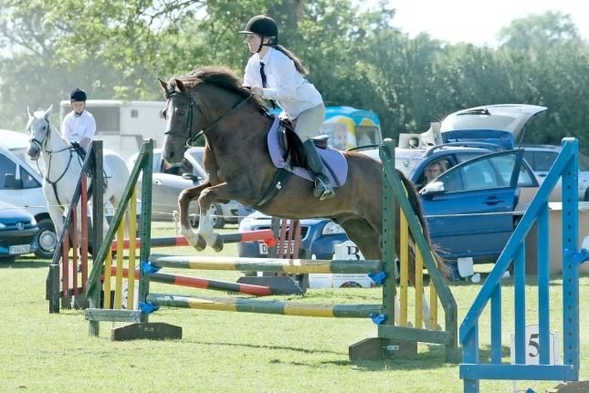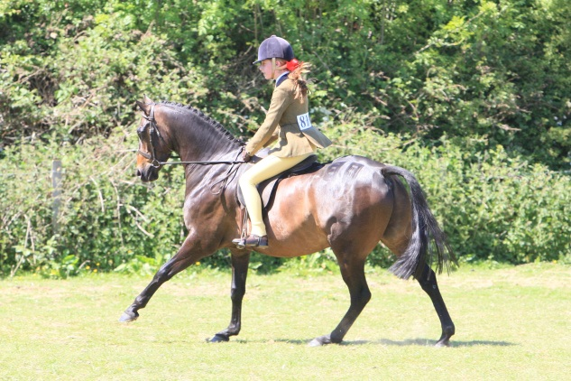*

DDRC END OF YEAR CHAMPIONSHIP

DDRC runs an end of season championship for our members.

During the season, all fully paid up members are awarded points depending on their placings in each class at each show. Points are awarded to the horse/pony/rider/handler combination.

The points are awarded as follows:

1stPlace = 6 points

2nd Place = 5 points

3rd Place = 4 points

4th Place = 3 points

5th Place = 2 points

6th Place = 1 point

At the end of the season, these points are added together and the member with the largest number of points for each class wins a Championship Trophy for that class. The second highest placed member wins a Reserve Champion Medal and Rosette. These trophies get presented to the winners at our Presentation Evening which takes place in October/November time.

Please make entries clear by using the same name throughout for the horse/pony (and the

rider)

Congratulations to all of our 2014 Champions and Reserve Champions.

**

RING ONE – 9.30AM START

CLASS 1 –*THE PETER PAN STAKES*

Open to any horse/pony/rider/combination not to have been placed 1st in any DDRC 70cm (2’3”) class in the prior calendar year. If you compete in this class you may compete in classes 10, 11 and 12 in Ring 2.

(CTR Rule - The competition is open to all horses/ponies who have not won any notional money BS on the date of the show at which they qualified. Any winnings subsequent to qualifying will not be taken into account).

Jumps not to exceed 70cm (2’3”) in the first round. Judged under table A7.

Will be split if numbers exceed 15, into the following sections: a)Horses

b)Ponies

**CLASS 2 – *NOVICE JUMPING***

Open to any horse/ponyrider/combination not to have been placed 1st in any DDRC 80cm (2 ft 6”) class in the prior calendar year. **Horse/pony/rider not to have competed in any class in Ring 2 (with exception to Classes 10 & 12).**

(CTR Rule - This competition is open to all horses/ponies who have not won more than £50 notional BS on the date of the show at which they qualified. Any winnings subsequent to qualifying will not be taken into account).

Jumps not to exceed 80cm (2’6”) in the first round. Judged table A7.

Will be split if numbers exceed 15 into the following sections: a)Horses

b)Ponies

**CLASS 3 – SCURRY**

Open to any horse/pony/rider/combination.. One round against the clock. Fastest Clear Round wins. Judged on time and faults incurred. Jumps not to exceed 80cm (2’6”).

**CLASS 4 – *INTERMEDIATE***

Open to any horse/pony/rider/combination.

**Horse/ponyrider/combination not to have competed in class 1 or any class in Ring 2 (with exception to Class 10 & 12)**

Jumps not to exceed 80cm – 90cm (2’6” – 2’9”) in the first round. Judged under two phase ruling.

Will be split if numbers exceed 15 into the following sections: a)Horses

b)Ponies

**CLASS 5 – *OPEN***

Open to any horse/pony/rider/combination

**Horse/pony/rider/combination not to have competed in any class in Ring 2 (with exception to Class 10 & 12) or Classes 1 and 2.**

Jumps to be 90cm – 1m (2’9” – 3’0”) in the first round. Judged under table A7.

Will be split if numbers exceed 15 into the following sections: a)Horses

b)Ponies

RING TWO – 9.30AM START

CLASSES 7, 8 & 9 ARE STRICTLY FOR BEGINNERS

**CLASS 6 – *NURSERY STAKES***

**Horse/pony/rider/combination not to have competed in any class in Ring 1, and may not compete in classes 9 and 10.**

Riders 12 years and under.

Jumps approx 40cm (1’3”) in the first round. Jump off against the clock.

This class will be split into the following sections: a) Lead Rein b) Ridden

**CLASS 7 – JUNIOR *BEGINNERS JUMPING***

**Horse/pony/ rider/combination not to have competed in any class in Ring 1. Riders not to be lead.**

Jumps approx 50cm (1’6”) in the first round. Jump off against the clock. For competitors aged 17 and under.

**CLASS 8 – ADULTS *BEGINNERS JUMPING***

**Horse/pony/ rider/combination not to have competed in any class in Ring 1. Riders not to be lead.**

Jumps approx 50cm (1’6”) in the first round. Jump off against the clock. For competitors aged 18 and over.

**CLASS 9 –*PAIRS***

**Open to any horse/pony/ rider/combination.**

### Jumps approx 60cm - 70cm (2’0” to 2’3”) Class will be run as a handicap. Ring 1 entrants will jumps 70cm, Ring 2 entries will jump 60cm.This class will split into Ring 1 and Ring 2 entrants if entries exceed 15. Only enter Ring 2 Section if both riders are from Ring 2. All other pairs should be in the Ring 1 Section.

**CLASS 10 – NEED FOR SPEED**

**Open to any horse/pony/ rider/combination.**

Jumps approx 60cm - 70cm (2’0” to 2’3”). This will be over a shortened course of 6 fences. Teams must consist of 4 members, with the top three times to count. The team of 4 with the quickest aggregate time will be the winners. Any jumping faults will be incurred as faults not time penalties.

Team to assemble in changeover area; when one rider returns, the next one sets off. No baton will be passed. **Entries on the day at the secretaries caravan £20.00 per team. One team per entry form.**

**CLASS 11 – *DACORUM CHALLENGE CUP***

**Horse/pony/rider/combination may only have competed in classes 7, 8, 9 and 10 in Ring 2 or in class 1 in Ring 1.**

Jumps approx 60cm – 70cm (2’0” to 2’3”) in the first round

Will be split into the following age groups: a) 12 years and under b) 13 years and over

This class will be judged under either Table A7 or two phase ruling depending on the number of entries.

**CLASS 12 – *PUISSANCE***

Jump will start at approx 60cm (2’0”). This class is not against the clock. There will be an optional fence, errors at which will not be penalised, followed by a spread fence and the puissance wall, which will be raised before each round.

Competitors who withdraw or retire are placed equal with those who are eliminated in the same round.

Class will be split into Ring 1 and 2 entrants. **Entries on the day at the secretaries caravan £5.00.** Late entries may be taken on the gate.This class will be split, with a minimum number of 15, into:

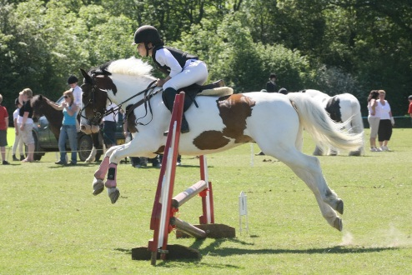a) Horses and b) Ponies

RING THREE – 9.00AM START

IN HAND SHOWING

Once the rope on the showing rings has been fastened, there is STRICTLY no admittance to the ring by any competitors.

CLASS 13 –*YOUNG STOCK (IN HAND)*

*Photocopy of Passport to be presented on request.* Any horse/pony: 1,2 or 3 year old.

If there are sufficient entries the class will be split into:

1. 1 and 2 year olds
2. 3 year olds

This will be at the discretion of the judge. Please give age of animal when entering class.

**CLASS 14 – *MOUNTAIN AND MOORLAND (IN HAND) – SMALL BREEDS***

Pure bred ponies of any age. Registered and unregistered. Shetlands, Dartmoor, Exmoor, Welsh A and Welsh B.

**CLASS 15 – *MOUNTAIN AND MOORLAND (IN HAND) –LARGE BREEDS***

Pure bred ponies of any age. Registered and unregistered. New Forest, Fell, Dales, Highland, Connemara, Welsh C and D.

**CLASS 16 – *YOUNG HANDLER – Sponsored in Memory of Yvonne Denchfield***

Horses or ponies of any age. Will be split into the following:

1. handler 11 years and under b) handler 12 years to 18 years.

Will be judged on the handler’s ability to show the horse/pony to the best advantage and neatness of dress of handler. A rosette will be presented to each competitor in this class.

**Note: Only those aged 14 and under are eligible to qualify for Horseradar CTR Champ**

**Note: Only those aged 16 and under are eligible to qualify for Think Pink Championships.**

**CLASS 17 – *PART BRED (IN HAND)***

Open to any horse/pony

**CLASS 18 – *COB (IN HAND)***

Horses or ponies of any age.

**CLASS 19 – *VETERANS (IN HAND) sponsored by The Icknield Veterinary Group***

*Photocopy of Passport to be presented on request.*

Open to any horse/pony over 15 years old (born either in or before 2000).

**Class 20 will not start before 1pm**

**CLASS 20 – *BEST CONDITION (IN HAND)***

Horse/pony and rider any age. Will be split into the following: a) Horse/pony stabled or part stabled

b) Horse/pony kept entirely at grass.

**CLASS 21 – *COLOURED & ODD COLOURED (IN HAND)***

Open to any Skewbald, Piebald, Appaloosa, Creams, Dun, Palomino, Roans, Spots, Paints.

Horse/pony of any age and height.

**CLASS 22 – *RIDING HORSE/PONY (IN HAND)***

Open to horses or ponies of Riding Horse Type of any age. The animal must be sound and in good condition.

**CLASS 23 – *DRIVING TYPE (IN HAND)***

Open to horses or ponies of any age. The animal must be sound and in good condition and suitable for driving.

Classes 14, 15, 17, 18, 19, 21, 22 and 23 will be split, with a minimum number if 15, into the following sections: a) Horses b) Ponies

RING FOUR – 9.00AM START

RIDDEN SHOWING

Once the rope on the showing rings has been fastened, there is STRICTLY no admittance to the ring by any competitors.

CLASS 24 –*BEST TURNED OUT (RIDDEN)*

Will be judged on the dress of the rider and the neatness and overall impression of the horse/pony and rider. Lead rein accepted in this class and can qualify for Horseradar CTR Championship.

**CLASS 25 – *BLEMISHES DON’T COUNT (RIDDEN)***

Open to horses or ponies of any age. The animal must be sound and in good condition. Lead rein accepted in this class.

**CLASS 26A – *FIRST PONY (LEAD REIN) Sponsored in Memory of Yvonne Denchfield***

Open to any pony 4 years old and over and not exceeding 13.2hh. Must be in snaffle bridle.

Riders not to have attained their 12th birthday before January 1st 2012. A rosette will be presented to each competitor in this class. **If competitors are entering classes 26A and 26B then they must compete hors concours in Class 26B.**

**(CTR Rule –** This is open for ponies not exceeding 122cm (12hh). Open to mares and geldings 4 years and over. Children must not have reached their 9th birthday on 1st Jan 2013)

**CLASS 26B – *FIRST PONY (RIDDEN) Sponsored in Memory of Yvonne Denchfield***

Open to any pony 4 years old and over and not exceeding 13.2hh. Must be in snaffle bridle.

Riders not to have attained their 12th birthday before January 1st 2011. A rosette will be presented to each competitor in this class. **If competitors are entering classes 26A and 26B then they must compete hors concours in Class 26B.**

**(CTR Rule –** This is open for ponies not exceeding 128cm (12.2hh). Open to mares and geldings 4 years and over. Children must not have reached their 11th birthday on 1st Jan 2013)

**CLASS 27 – *RIDING HORSE/PONY (RIDDEN)***

Open to any horse/pony. Only **HORSE** Section are qualifiers for Horseradar CTR Championship – Horses must be 148cm (14.2hh) or above for this section.

**CLASS 28 – *RIDDEN HUNTER***

Open to horses or ponies of any age of Hunter Type. The animal must be sound and in good condition. **For Horseradar CTR Qualifiers – Horses must be 153cm (15hh) or above.**

**CLASS 29 – *MOUNTAIN AND MOORLAND (RIDDEN) SMALL BREEDS***

Pure-bred ponies of any age. Registered and Unregistered. Shetlands, Dartmoor, Exmoor, Welsh A and Welsh B. Lead rein accepted in this class. Please note you may be asked to trot and canter in this class. **(Lead reins cannot qualify for Horseradar CTR Championship).**

**CLASS 30 – *MOUNTAIN AND MOORLAND (RIDDEN) LARGE BREEDS***

Pure-bred ponies of any age. Registered and Unregistered. New Forest, Fell, Dales, Highland, Connemara, Welsh C and D. **(Lead reins cannot qualify for Horseradar CTR Championship).**

Classes 24, 25, 27 and 28 will be split, with a minimum number if 15, into the following sections: a) Horses b) Ponies

RING FOUR – 9.00AM START

RIDDEN SHOWING

Once the rope on the showing rings has been fastened, there is STRICTLY no admittance to the ring by any competitors.

**Class 31 will not start before 1pm**

**CLASS 31 – *VETERANS (RIDDEN) sponsored by The Icknield Veterinary Group***

*Photocopy of Passport to be presented on request.*

**Open to any horse/pony over 15 years old (born either in or before 2000). Lead rein accepted in this class. Please note you may be asked to trot and canter in this class.** (Please note for Horseradar CTR Qualifiers lead reins cannot qualify)

**CLASS 32 – *REHABILITATED RACEHORSE (RIDDEN)***

Open to any Thoroughbreds who have retired from racing and are now retrained. Must be 15hh (153cm) or over. Must be registered with Wetherbys General Stud book or an overseas equivalent. Proof to be available on request. Horses must have raced and be able to show a race record. Riders must have reached their 17th birthday by 1st January 2015 to qualify for Horseradar CTR Championship

**CLASS 33 – *PART BRED HORSE/PONY (RIDDEN)***

Open to any part bred horse/pony of any age.

**CLASS 34 – *COLOURED & ODD COLOURED HORSE/PONY (RIDDEN)***

Open to any Skewbald, Piebald, Appaloosa, Creams, Dun, Palomino, Roans, Spots, Paints.

Horse/pony of any age and height. . **(Lead reins cannot qualify for Horseradar CTR Championship).**

**CLASS 35 – *COB (RIDDEN)***

Horses/ponies of any age. Must be between over 148cm to qualify for Chiltern Equine Clinic CTR Championship. May be shown hogged, plaited or unplaited

**CLASS 36 – *FOREIGN BREEDS (RIDDEN)***

Horses/ponies of any age and height. Registered and Unregistered. The animal must be sound and in good condition. Andalusians, Luzitanos, Lippizaners, Quarter Horses, Saddlbreds, Morgans,Paints, Paso Finos, Knabstruppers, Haflingers, Mustangs, Appaloosas (any other foreign breed that are not warmblood or British breeds, British Natives or ARABS.

Classes 31, 32, 33, 34 and 35 will be split, with a minimum number if 15, into the following sections: a) Horses b) Ponies

### Description: DDRC 005.jpgLCY_0070a

#### RING FIVE

**CLEAR ROUND** - to run throughout the day - £3.00 per round. The height of jumps will be altered at intervals. Rosettes to all clear rounds.

# RING SIX

### **FUN CLASSES**

**1PM START**

The following classes will run subject to entries (minimum 3)

1. Prettiest Mare or Handsomest Gelding
2. Pony the Judge would most like to take home
3. Pony/Horse most suitable for Pony Club/Riding Club activities (incl. a small jump)

Entry £3 per event.

The above classes will NOT qualify for the End of Season Championship.

The above classes (ring 6) will be split, with a minimum number if 15, into the following sections: a) Horses b) Ponies

# DDRC CLUB RULES

1. Riding Jackets, jodhpurs and Riding Boots must be worn by all mounted competitors. Un-mounted competitors should be correctly dressed for showing. Trainers are not allowed.
   1. In the case of extreme hot weather, riding jackets may be forfeited but a white long sleeved shirt/blouse must be worn. This is at the judge’s discretion.
2. Riding hats with chinstraps must be worn by all persons when mounted on any horse/pony on any part of the showground. Hats must be according to current BHS standards.
3. It is the rider/handler’s responsibility to ensure their horse/pony is tacked up correctly. Random spot checks may be carried out.
4. Chinstraps must be fastened at all times. Failure to do so will result in automatic elimination.
5. The organisers reserve the right to refuse any entry to any class or entry to the showground without stating a reason
6. No entries will be accepted unless accompanied by the correct fee and all cheques must be backed by a valid cheque guarantee card. Cheques must have the name and address of the signatory on the reverse of the cheque or they will not be accepted.
7. The organisers reserve the right to request a height certificate of any animal and proof of age of riders where there is an entry requirement We also reserve the right to measure any horse/pony Please note that for veterans and youngstock a copy of a passport must be available on request.
8. Objections must be made within 30 minutes of the incident and accompanied by a deposit of £20.00 which will be forfeited if the objection is overruled
9. The organisers will not accept any responsibility or liability for loss, damage or illness to any property, person or animal however caused
10. Dogs must be kept on a leash at all times on any part of the showground.
11. No horse or pony under the age of 4 years may be ridden on the showground
12. No galloping or cantering on the showground is allowed except as required by a judge or in the practice areas.
13. Improper use of whips or spurs at any time on the showground will result in elimination. The wearing of Spurs is NOT allowed in Ring 2.
14. A riders age will taken as from January 1st 2015
15. Club membership runs from May 1st - April 30th.
16. Points will only be awarded from the date of MEMBERSHIP RENEWAL or in the case of a new member, the DATE OF JOINING the club.
17. Members must attend a minimum of 2 shows during the year to qualify for the DDRC points system.
18. The ruling of any judge or official is final and any person found arguing will be asked to leave the showground
19. Any person found mistreating any animal or using bad language will be asked to leave the showground
20. Class trophies will only be awarded to fully paid up members who come first in each class.
21. A 'Best Members' rosette will be awarded to the highest placed fully paid up member
22. The organisers reserve the right to either alter or cancel any class and to amalgamate any class where there are insufficient entries
23. Any member winning the overall BEGINNERS or NOVICE jumping championship in rings 1 or 2 will not be eligible to enter the Horse/Pony that won the championship in that class again. Any rider discovered to have done this will have their points for the end of season trophies deducted.
24. Points are accumulated on rider/horse or pony and handler/horse or pony and not on a membership basis.
25. Once the rope on the showing rings has been fastened, there is STRICTLY no admittance to the ring by any competitors.
26. A horse or pony may now jump hors concours immediately after its competitive round and not wait until the end of the class. The horse/pony who has jumped hors concours will remain hors concours in that ring for the rest of the day.
27. Members must have their DDRC membership cards with them in the ring before they can be awarded a trophy. If the card is not presented in the ring when requested, the trophy will not be presented.

# CTR CHAMPIONSHIP QUALIFIER RULES

Showjumping

1. Riders must be a member of Chiltern & Thames Rider. Riders must have obtained a membership number from Chiltern & Thames Rider BEFORE entering a qualifier. If they do not have a membership number they cannot qualify.

This can be done online at a cost of £18.00 at www.chilternrider.co.uk/Membership/showmembers.htm or by phone on 01582 748983

1. Riders cannot qualify unless they have a valid membership number for the 2015 season with the prefix SSJ15
2. CTR Membership numbers must be entered on the DDRC membership form when entering.
3. First, Second and Third placed horses and ponies qualify in each class. The qualification can pass down the line as far as 5th place
4. Horses & Ponies must go clear in the first round to qualify.
5. Chiltern & Thames Rider will notify those who have qualified.
6. Please note: Horse/pony combinations cannot enter more than two classes and they must be consecutive i.e. mini and novice, novice and small open, small open and open except for the equestrian.co.uk jump challenge which can be entered as a third class.

Showing

1. Riders must be a member of Chiltern & Thames Rider. Riders must have obtained a membership number from Chiltern & Thames Rider BEFORE entering a qualifier. If they do not have a membership number they cannot qualify.
2. This can be done online (www.chilternrider.co.uk or by phone 01582 748983)
3. Riders cannot qualify unless they have a valid membership number for the 2015 season with the prefix SH15.
4. CTR Membership numbers must be entered on the DDRC entry form when entering
5. Qualification can pass down the line as far as 4th place.
6. Chiltern & Thames Rider will notify those who have qualified. Judges do not award Q cards or sign cards.
7. Passports must be available if asked for by a judge or an official of the show.
8. Horses and Ponies who have qualified for or competed at HOYS (except SEIB Search for a Star) in the years 2013, 2014, or 2015 are not eligible for the C&T Rider Championships.
9. All Stallions and Colts must be shown bitted.
10. Stallions must be shown/ridden by competitors who have obtained their 14th birthday by 1st January 2015.
11. Lead Reins are only permitted in the Lead Rein Classes and Best Turned Out

Please see Classes for any additional rules specific to that class.

**THINK PINK QUALIFICATION**

**Youngstock**

Qualifications are given to the highest placed two, not to have already qualified in the top six. Qualification Cards will be provided to qualifying competitors.

Should there be more than 5 yearlings entered in the youngstock class, they will be split.

**Young Handler under 16**

Qualifications are given to the highest placed two, not to have already qualified in the top six. Qualification Cards will be provided to qualifying competitors.

**Diamond Show – June 2015**

The finals are to take place on the 5th September 2015 at Houghton Hall, PE28 2DY. The final classes will be split. The top ten from each final will go through to the evening performance for placing, Evening turnout encouraged. All finalists to receive a rosette. Think Pink shows raise money for Cancer Research UK. Find us on Facebook or [www.thinkpinkshow.co.uk](http://www.thinkpinkshow.co.uk)

DDRC ENTRY FORM 2015

**Show date: / / 2015**

|  |  |
| --- | --- |
| **Name:…………………………………….** | **Telephone No:……………………...** |
| **Address………………………………….:** | **Email:…………………………………...** |
| **Address:………………………………….** |  |
| **Postcode:…………………………………** |  |

**I have read the rules & regulations laid out in the schedule and agree to abide by them**

**Signed………………………………………………………….**

**How Did You Hear About Us (please tick)?**

Facebook 🖵 Riding Diary 🖵

Twitter 🖵 Chiltern Rider Magazine/Website 🖵

DDRC Website 🖵 East Anglia Rider Magazine/Website 🖵

Been to our Shows Before 🖵 Other (please state) 🖵

……………………………………………………

|  |  |  |  |  |  |  |  |  |
| --- | --- | --- | --- | --- | --- | --- | --- | --- |
| CLASS NO | RIDERS NAME | RIDERS  AGE (if under 18) | HORSE/  PONY NAME | HEIGHT HH | CLASS  SECTION  (A OR B) | DDRC MEMB. NO. | Chiltern Rider  Memb No | FEE |
|  |  |  |  |  |  |  |  |  |
|  |  |  |  |  |  |  |  |  |
|  |  |  |  |  |  |  |  |  |
|  |  |  |  |  |  |  |  |  |
|  |  |  |  |  |  |  |  |  |
| **Please make cheques payable to Dacorum and District Riding Club and write your name and address on the back of the cheque. Return this form with your payment to: DDRC SHOW SECRETARY, DEBBIE SHELDON, 15 BOURNEHALL AVENUE, BUSHEY, HERTS WD23 3AU. Please no calls after 9pm. Calls will be returned to land lines and texts to mobiles but not calls to mobiles.** | | | | | |  | First Aid Cover | £3.00  Per Competitor |
|  | TOTAL | £ |

# ENTRY FEES Members Non Members

Pre-Booked £5.00 £7.00

On The Day £8.00 £10.00

Need for Speed £20.00 per team

Chase Me Charlie £5.00 per competitor

For membership fee please see separate form

* **Entry forms must be received by Wednesday before the date of the show along with the correct payment to qualify for pre-entry prices.**
* A best member’s rosette will be awarded to the highest placed member in each class.
* Trophies are only awarded to a fully paid up member who is placed first in each class.
* POINTS will be awarded to members throughout the season with trophies awarded at the AGM. Points are awarded to the horse/pony/rider/handler combination. Members must attend a minimum of 2 shows during the year to qualify for this.
* Junior members must be under the age of 18 as at the 1st January 2015.